The inscriptions on the four faces of the columns base are:
England has saved herself by her firmness, and Europe by her example. Pitt
This Pillar was erected by HENRY COLLINGWOOD SELBY, a Magistrate of this County, to commemorate the persevering and victorious efforts of the British Empire by sea and land during an arduous struggle of XX years, and the signal successes of the Powers united with this Country at the close of that eventful period; the expulsion of the French from Russia after the burning of Moscow in MDCCCXII, the defeats of their armies in Germany in the memorable campaign of MDCCCXIII, the invasion of France, the surrender of Paris, the downfall of Napoleon Buonaparte, the reestablishment of the Bourbon monarchs, and the restoration of Peace to Europe in MDCCCXIV.
Vice-Admiral HORATIO VISCOUNT NELSON of the Nile defeated the French and Danish Fleets at Aboukir and Copenhagen, and fell in the decisive victory of Trafalgar achieved over the combined Navies of France and Spain in MDCCCV.
Field Marshal THE DUKE OF WELLINGTON having vanquished the Armies of France in Portugal and in Spain, at the Battles of Vimeira and Talavera, Salamanca and Vittoria, drove them beyond the Pyrennees, and advancing to the banks of the Garonne again overthrew them under the walls of Toulouse in MDCCCXIV.
The Right Honourable WILLIAM PITT directed the councils and energies of his country during the first years of a just and necessary war, and died in MDCCCVI, having established that wise and vigorous system of policy, which succeeding statesmen, emulous of his example, steadily pursued till they secured Independence for the Nations of the Continent and a Peace of unparalleled glory for this empire.

Visiting the Swansfield Peace Column

Explore Alnwick’s Heritage
Explore Alnwick’s rich heritage through the Alnwick Heritage website
Join one of the many local heritage groups. Find out more on the website.



Swansfield Peace Column
Celebrating the end of the Napoleonic Wars
A year early!
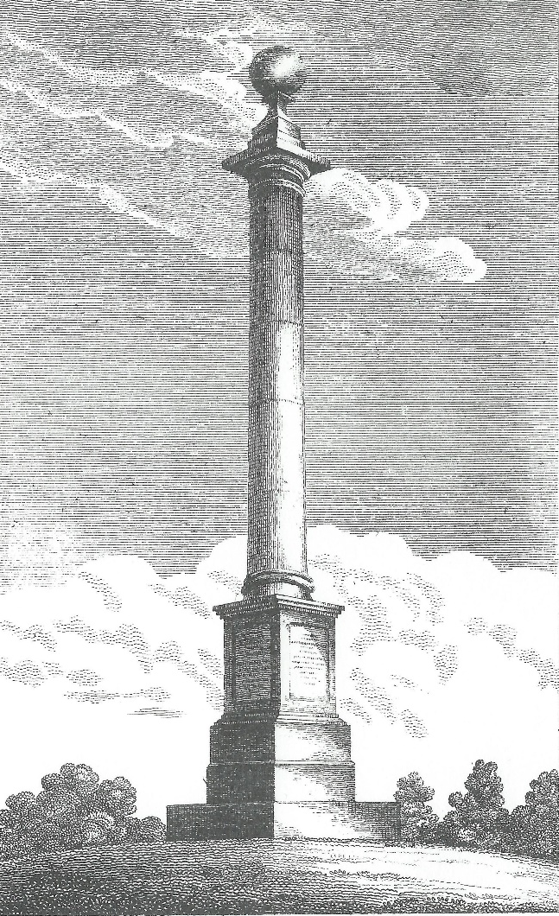
Engraving of Swansfield Peace Column from William Davison’s “A Descriptive and Historical View of Alnwick”

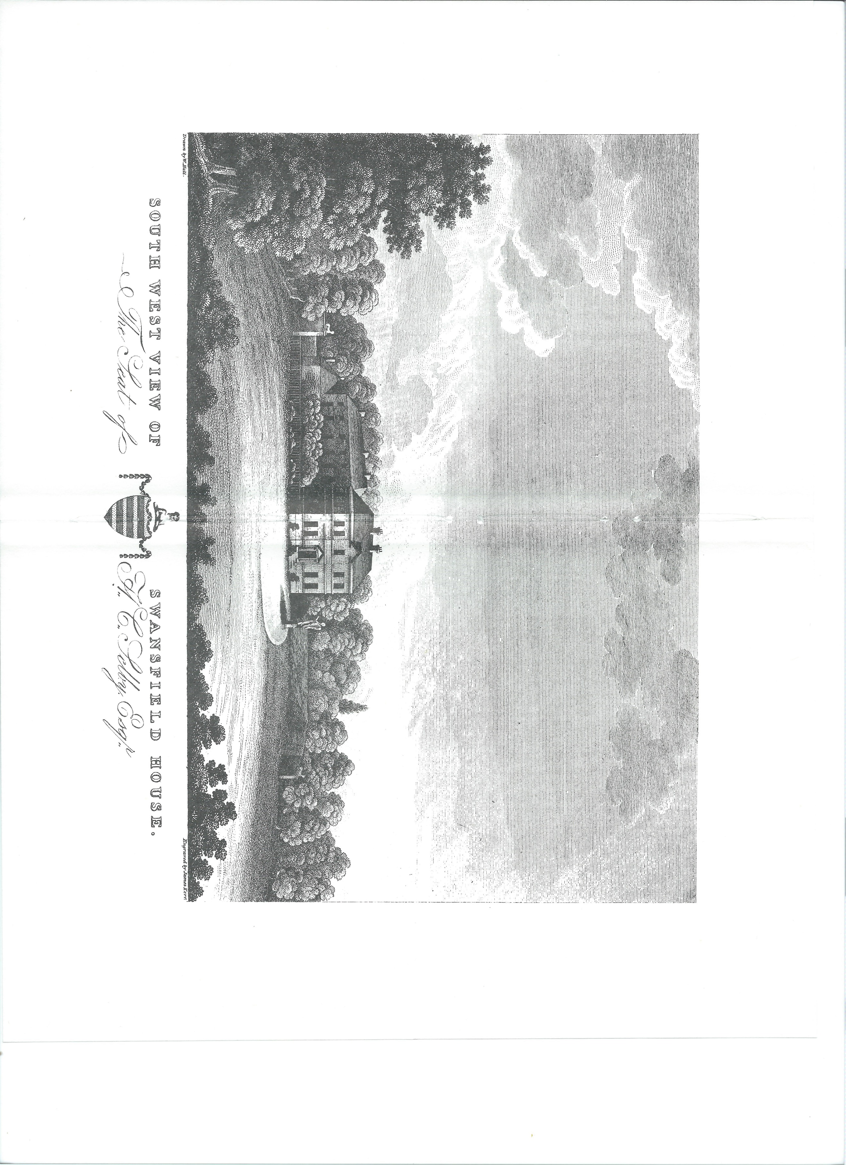
Swansfield House and the Peace Column
Swann’s Field, near Clayport Bank, was an ancient field, part of the possessions of the Knights of St John of Jerusalem. The old house, built in the late 17C or early 18C, is mentioned in 1769 as being held by Richard Grieve, who sold it to Henry Collingwood Selby Esq., the Duke’s steward.
Selby carried out extensive alterations to the house from 1823 onwards, the work being done by Robert Hall, mason of Alnwick, to the designs of John Dobson, the Newcastle architect.
Swansfield House from an engraving by James Kerr
The house sat within extensive parkland which today is occupied by the Alnwick Castle Golf Club. At the park’s highest point is an iron age settlement, which gives the area its name of Camphill.
Within the camp’s ramparts is the Swansfield Peace Column. Erected by Henry Selby, it commemorates what was thought to be the end of the Napoleonic Wars, following the 1814 Treaty of Paris.
The column was designed in accordance with ‘Vetruvius’ plan’, referring to the Roman architect who proposed certain proportions as being aesthetically ideal.
It was originally intended to have been topped by a statue of Peace and Victory, made from Coade Stone.
The peace was, however, short-lived, with Napoleon re-establishing his rule of France, before being finally defeated at Waterloo. The idea of topping the column with the Peace and Victory figure was abandoned, with the finishing feature instead being the simple ball we see today.
The Coade Stone ‘Peace and Victory’ figure was erected on the lawn of the old Swansfield House and can be seen on the engraving above. There is no trace of it today.
In 1975, following a serious fire, the house was demolished and replaced by the house we see today.
Coade Stone
Coade Stone is a ceramic material, developed in the late 18C by Mrs Caode. It allowed for highly detailed additions to buildings.
Local examples of Coade Stone include the four lions on the base of the Tenantry Column, and the plaques on the side of Brizlee Tower in Hulne Park.

